From Research Home Dashboard- Click “Reports” Section header to go to Epic Reporting Workbench
- Select Library tab
- Search on keyword: “Research”
- Click the Template: Find Patients- Generic Criteria- Research User ( to expand)
- Select the Report :”MyChart Research Recruitment Using MRN Patient List ( Public Report)
- Click Edit- to make a personal copy – ( which you can save , use and reuse )
  - This opens the Report Setting
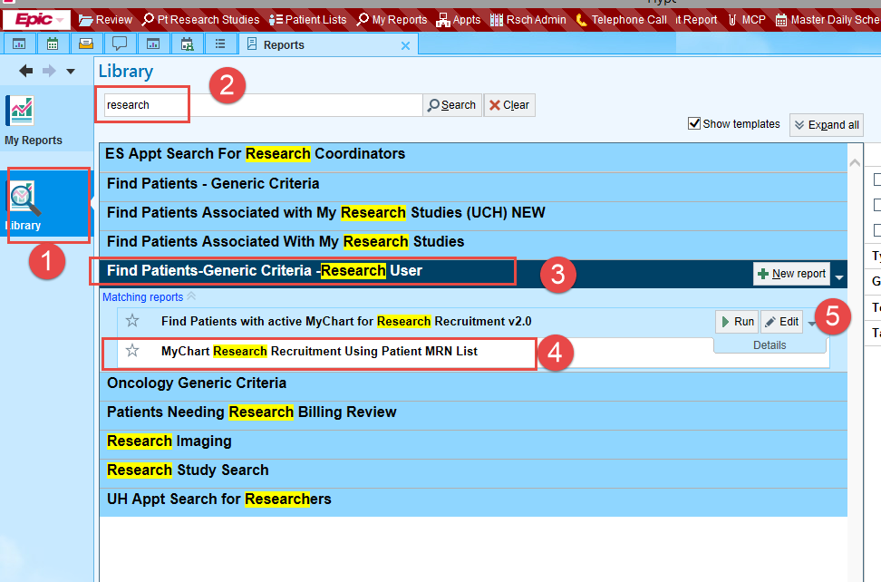

- Click : Save As - to make a personal copy
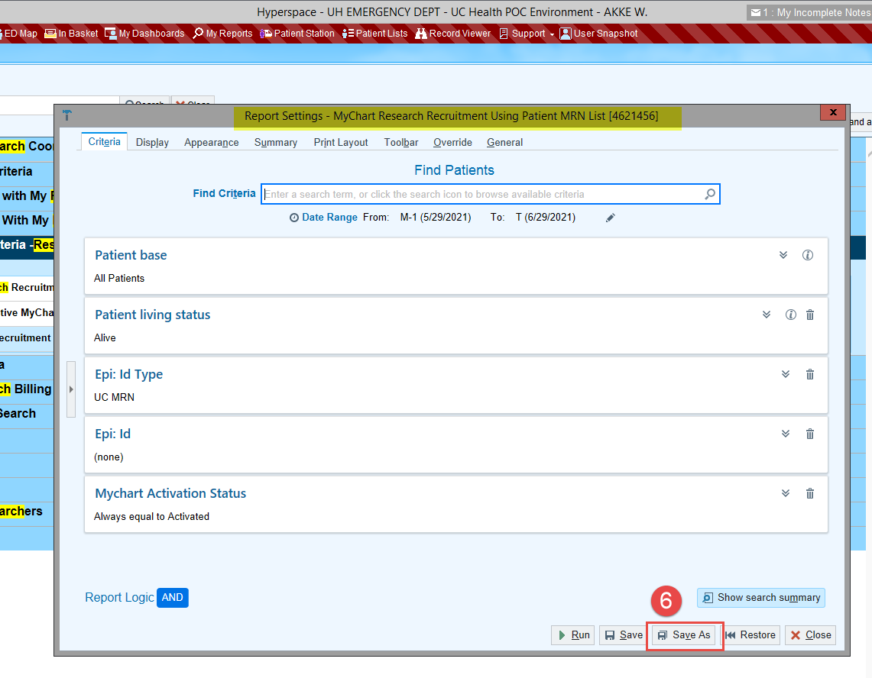

- Give the Copy a Name- Add your intials as a prefix ( can also add a date )
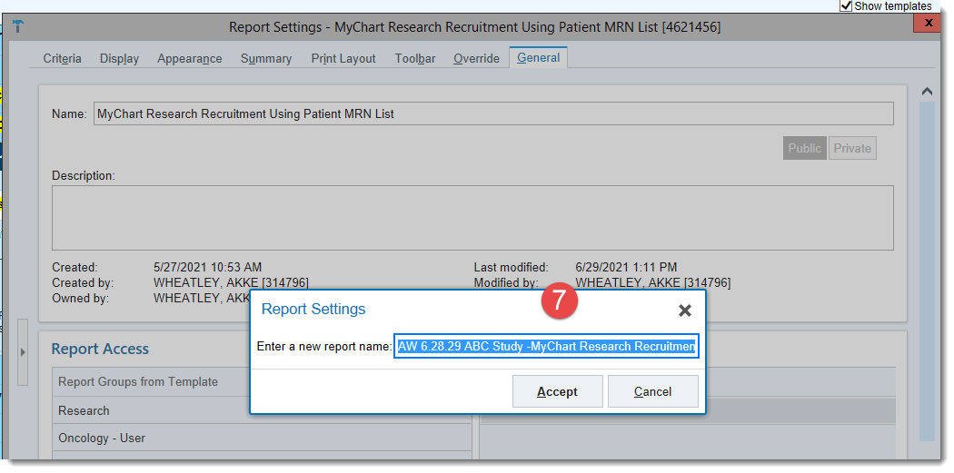
- Report becomes your personal copy
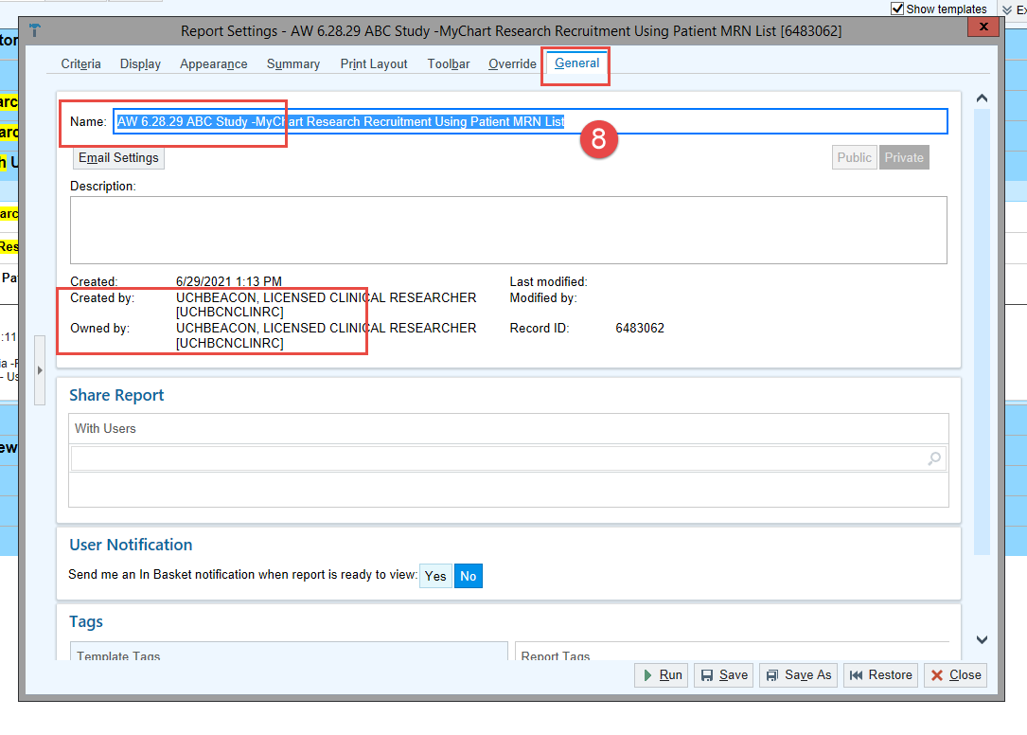
- On your Personal Copy – go to the Criteria Tab to enter MRN numbers
- Add in the EPI:IC Field
- you can tab down the MRN List to enter quickly
- Click Save and Run

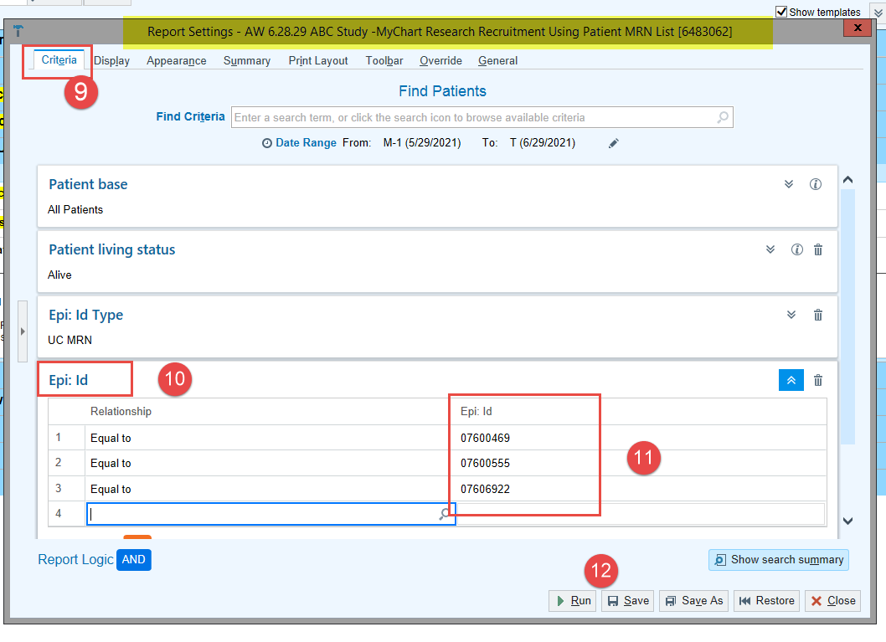

Review Report Results:
Select a Patient - Review Snapshot Report
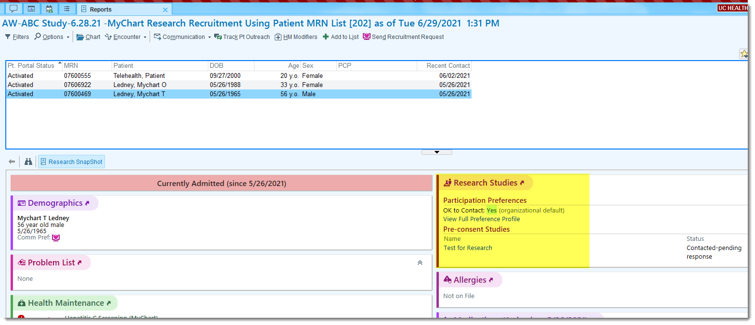

Send Recruitment Request for Multiple Patients –
Use CTL +Click- to multi Select Patients
- Click “Send Recruitment Request
- Select Research Study - Patient Facing Study Nat and Desciption will show
- Click Accept ( to send message)

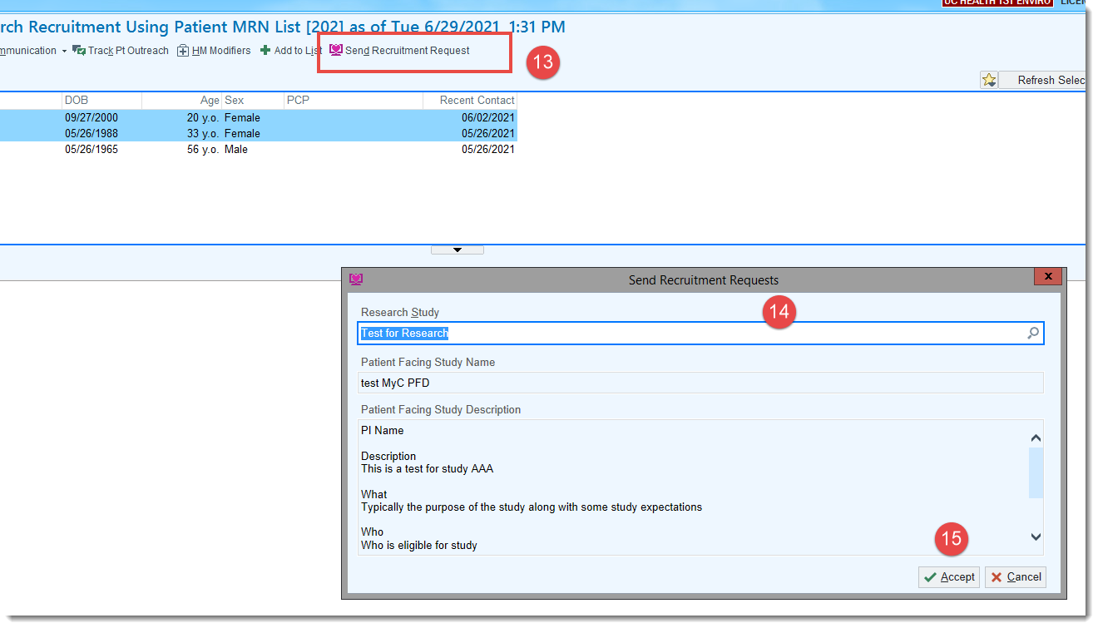

Verify that Patient Enrollment status updated to : “Contacted Pending Response”
- From the Report- click Refresh and
- review the Snapshot Report (2)
- From Chart Review – open chart and drill to the Enrollment Record Detail
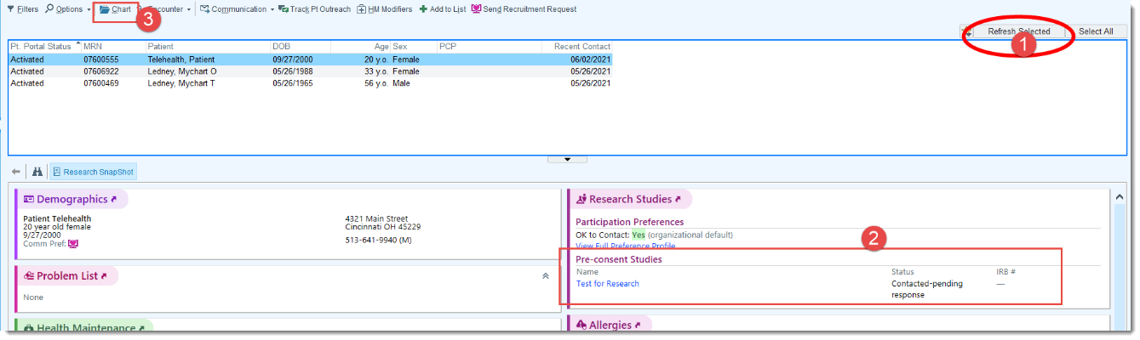

To Find Enrollment Record Details- Open Research Studies Activity – Click Arrow by Study Name
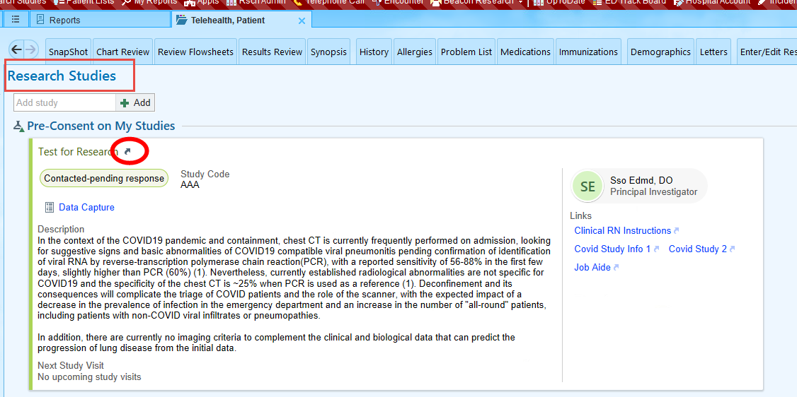

Click Additional Information to open the Enrollment Record
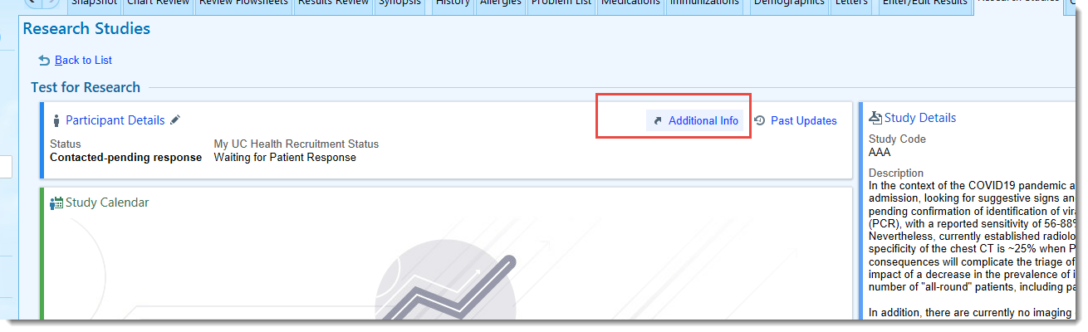
Review Enrollment Details
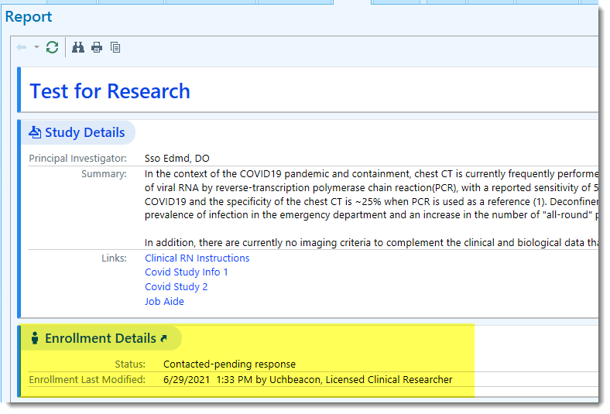

Reporting Tips:
You can “Favorite” your new Report so it shows up on your Research Dashboard
From the Library – click the Star next to the report
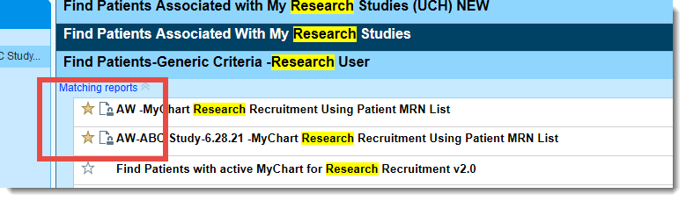
From Research Home Dashboard/ Favorite Reports section you can View and Edit the report anytime

