Send calendar invite to: DivisionLabServices@ucmail.uc.edu
Title: STUDY NAME | Patient ID (if known) | Visit #

Meeting Description:
Labs to be collected for us to process: Pre-dose PK, 1hr post dose PK, 4hr post dose PK, etc.

Will you need pick up services: yes/no [call the lab when samples are ready for pick up if requesting this service]

Coordinator Contact Information: Jane Doe 888-888-1234

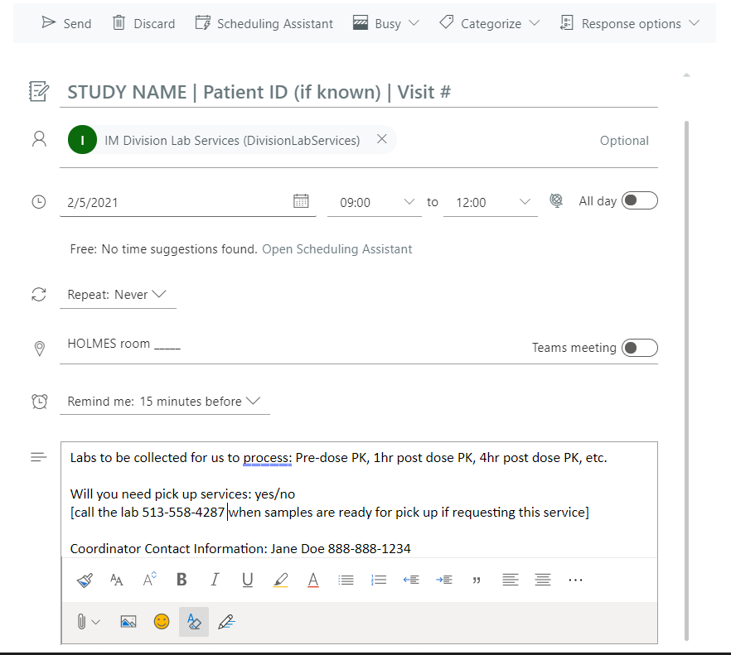

Make sure the invite encompasses the entire duration of the visit [example: if there are several PK draws make the appointment for 1hr prior to first draw and 1hr after last draw to account for delays]

